program FinishTime;

uses Crt; //To clear screen when executing

var //variables

schoolname:string; //string,real,integer are data types

athfname:string;

athlname:string;

finishingtime,averagetime,fastesttime:real;

x,event1,event2,event3,event4:integer;

menu:integer;

count:integer;

begin

fastesttime:=1000.00; //fastest time set at 1000.00

averagetime:=0; //average time ran for each event

count:=0; //count the number of athletes

TextColor(lightgreen);

writeln('');

writeln('');

writeln('');

writeln('');

writeln('Enter the following numbers IN THE BRACKET to choose any event:'); //Menu to choose any event

writeln('');

writeln('......100M(1)......');

writeln('');

writeln('......200M(2)......');

writeln('');

writeln('......400M(3)......');

writeln('');

writeln('......800M(4)......');

writeln('');

writeln('...............................................................');

readln(menu);

ClrScr;//Clear screen

if(menu=1)then

begin

for event1:= 1 to 4 do //for loop for number of 4 athletes

begin

writeln('100M RUNNERS');

count:=count+1; //counting athletes

writeln('Athlete #',count);

writeln('Enter the name of the school:'); //inputs to accept values

readln(schoolname);

writeln('Enter Athlete First Name');

readln(athfname);

writeln('Enter Athlete Last Name');

readln(athlname);

writeln('Enter Finishing Time');

readln(finishingtime);

writeln('');

if (finishingtime<fastesttime)then //determine the fastest time ran

begin

fastesttime:=finishingtime;

averagetime:=averagetime+finishingtime;

averagetime:=averagetime/count; //calculate average time ran

readln;

end;

end;

writeln('');

writeln('100M Male Fastest Time:',fastesttime);

writeln('The Average 100M Time Ran:',averagetime); //output of results

readln;

end;

if(menu=2)then

begin

for event2:= 1 to 4 do //another for loop collect data 4 times

begin

writeln('200M RUNNERS');

count:=count+1;

writeln('Athlete #',count);

writeln('Enter the name of the school:');

readln(schoolname);

writeln('Enter Athlete First Name');

readln(athfname);

writeln('Enter Athlete Last Name');

readln(athlname);

writeln('Enter Finishing Time');

readln(finishingtime);

writeln('');

if (finishingtime<fastesttime)then

begin

fastesttime:=finishingtime;

averagetime:=averagetime+finishingtime;

averagetime:=averagetime/count;

readln;

end;

end;

writeln('');

writeln('200M Male Fastest Time:',fastesttime);

writeln('The Average 200M Time Ran:',averagetime);

readln;

ClrScr;

end;

if(menu=3)then

begin

for event3:= 1 to 4 do

begin

writeln('400M RUNNERS');

count:=count+1;

writeln('Athlete #',count);

writeln('Enter the name of the school:');

readln(schoolname);

writeln('Enter Athlete First Name');

readln(athfname);

writeln('Enter Athlete Last Name');

readln(athlname);

writeln('Enter Finishing Time');

readln(finishingtime);

writeln('');

if (finishingtime<fastesttime)then

begin

fastesttime:=finishingtime;

averagetime:=averagetime+finishingtime;

averagetime:=averagetime/count;

readln;

end;

end;

writeln('');

writeln('400M Male Fastest Time:',fastesttime);

writeln('The Average 400M Time Ran:',averagetime);

readln;

ClrScr;

end;

if(menu=4)then

begin

for event4:= 1 to 4 do

begin

writeln('800M RUNNERS');

count:=count+1;

writeln('Athlete #',count);

writeln('Enter the name of the school:');

readln(schoolname);

writeln('Enter Athlete First Name');

readln(athfname);

writeln('Enter Athlete Last Name');

readln(athlname);

writeln('Enter Finishing Time');

readln(finishingtime);

writeln('');

if (finishingtime<fastesttime)then

begin

fastesttime:=finishingtime;

averagetime:=averagetime+finishingtime;

averagetime:=averagetime/count;

readln;

end;

end;

writeln('');

writeln('800M Male Fastest Time:',fastesttime);

writeln('The Average 800M Time Ran:',averagetime);

readln;

ClrScr;

end;

end. //end of program

Execution

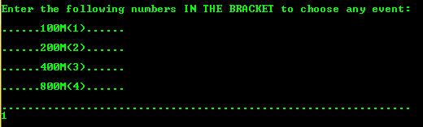

Screenshot 1 showing a menu to choose events. ‘1’ was entered to choose 100M.

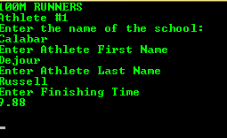

Screenshot 2 Entering information for 4 athletes according to loop.

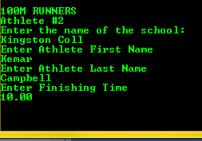

Screenshot 3

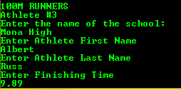

Screenshot 4

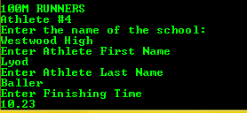

Screenshot 5 Final entry

**Results:**



Screenshot 6 Out of 4 athletes ‘Dejour Ressull’ has the fastest time of 9.88s.